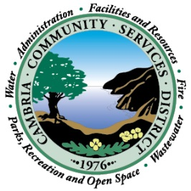
NOTICE OF CANCELLATION OF RESOURCES & INFRASTRUCTURE COMMITTEE REGULAR MEETING

The Cambria Community Services District
Resources & Infrastructure Committee Regular Meeting scheduled for May 14, 2019 at 3:00 p.m. has been cancelled. A Special Meeting has been scheduled for Tuesday, May 7, 2019 at 3:00 p.m. The Special Meeting will be held at 1000 Main Street, Cambria, CA 93428.

Posted April 30, 2019 at 4:30 p.m.

